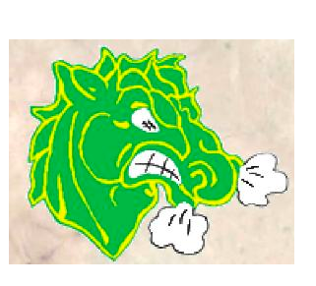
McCreary Minor Hockey
Parent Code of Conduct (from Hockey Canada)
1. I will not force my child to participate in hockey.

2. I will remember that my child plays hockey for his/her enjoyment, not mine.

3. I will encourage my child to play by the rules and to resolve conflicts without resorting to hostility or violence.

4. I will teach my child that doing one’s best is as important as winning, so that my child will never feel defeated by the outcome of a game / event.

5. I will make my child feel like a winner every time by offering praise for competing fairly and trying hard.

6. I will never ridicule or yell at my child for making a mistake or losing a game.

7. I will remember that children learn best by example.

8. I will applaud good plays / performances by both my child’s team and their opponents.

9. I will never question the official’s judgment or honesty in public.

10. I will support all efforts to remove verbal and physical abuse from children’s hockey activities.

11. I will respect and show appreciation for the volunteer coaches who give their time to provide hockey experiences for my child.

PLEASE REMEMBER – The goal of this organization is to create lifelong fans of the game of hockey. Sport gives our children an opportunity to grow, to appreciate what they have, and to learn to respect those around them. Our ultimate goal is not to create the next great NHL player, but to watch our children grow, and help them to succeed along the way.
**Violations of the code of conduct will result in a meeting with McCreary Minor Hockey Board members. Disciplinary action may include removal from minor hockey events, including games in other locations.
***Hockey Manitoba also requires at least one parent in each family to complete the online Respect In Sport for Parents program.
NAME: DATE:
TEAM:
SIGNATURE:

